***Open House Checklist***

**Prior to Open House**

* Print “Quick Flyer” in HH Presentation
* Print PCDs
* Print MLS Printouts
* Advertise on MLS
* Best Buy Ad in D&C or other paper (Company Paid)
* 2 Line Open (Company Paid)
* Advertise on Professional FB-Insta Page/Personal FB-Insta Page (Office will post on Office FB Page)
* GRAR Marketing Store Mailing
* Email your sphere via Engage CRM
* Place Open House Rider on For Sale Sign with Day/Hours of Open

**Day of Open House**

* Arrive Early
* Open House FB Live with Tour
* 5-5-10
* Open Signs
  + At Property
  + At Major intersections close to open
* Open Flags/Balloons
* Shovel/Salt (Winter)

**Items for Open**

* Turn on Lights
* Hide unwanted items
* Paper Sign-in or
* Open2Close or
* Individual Feedback form
* Plastic Frames w/ Flyers and info
* Business Cards w/ Holder
* Fair Housing Flyer
* Masks/Booties/Gloves/Hand Sanitizer/Wipes
* Buyer Book
* Quick Flyers
* 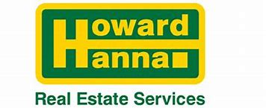PCD
* MLS Printout
* Mortgage Lender Flyers
* HH Pens
* Mints/Candy
* Chip Clips
* Calendars
* Portable Chair/Table (Vacant House)
* Source of Music

**After Open House**

* Pick up your items
* Put back any hidden items
* Put clients into Open2Close
* Follow up with any leads
* Fill in the Seller/Agent with feedback
* ******Social Post thanking everyone for Successful Open House